**Q1)** **Write a program to check a string to be palindrome or not.**

**Program instruction:-**

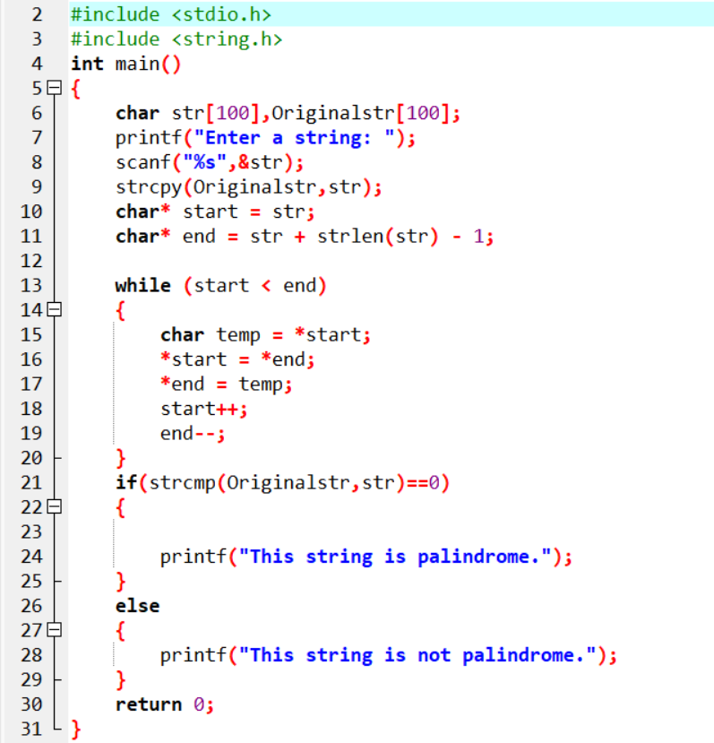

**Output:-**

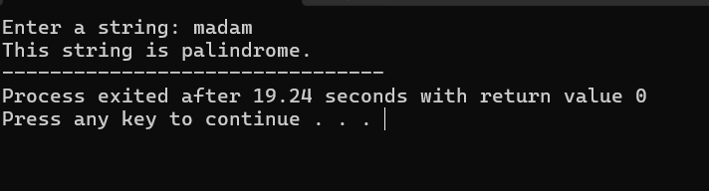

**Q2)** **You have two arrays X=[3,5,7,9,11,13,17,19,23,29] and its frequency of occurrence F=[2,3,2,3,4,2,4,3,4,2]. Write a program to compute the weighted average.**

**Program instruction:-**

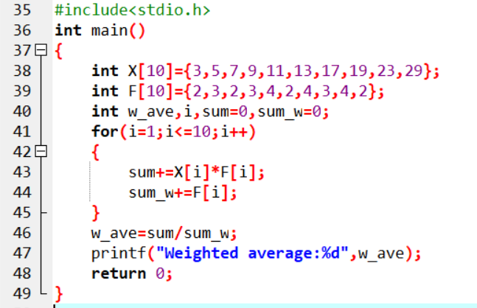

**Output:-**

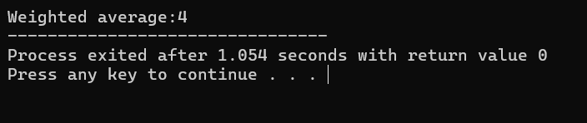

**Q3)** **Write a program to perform the sorting of the array [45,32,17,84,77,65,7,54] in ascending order.**

**Program instruction:-**

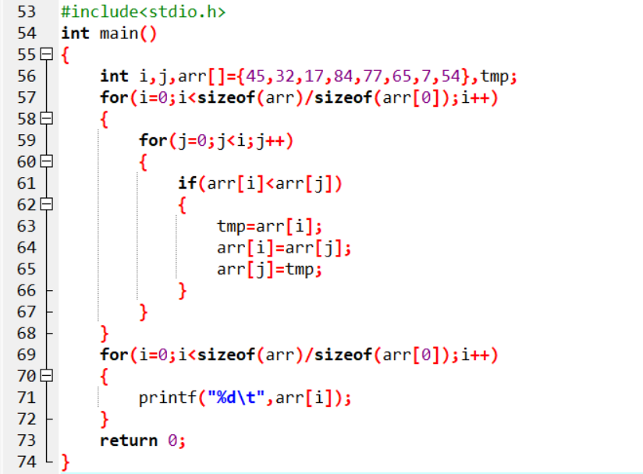

**Output:-**

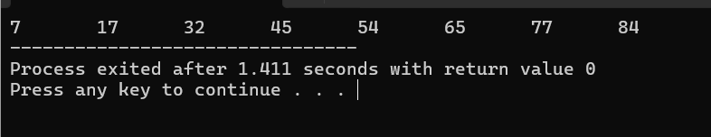

**Q4)** **Given a table of input-output mapping below, Write a program to implement the mapping.**

|  |  |  |
| --- | --- | --- |
| **A(input)** | **B(input)** | **Y(output)** |
| **0** | **0** | **1** |
| **0** | **1** | **1** |
| **1** | **0** | **0** |
| **1** | **1** | **1** |

**Program instruction:-**

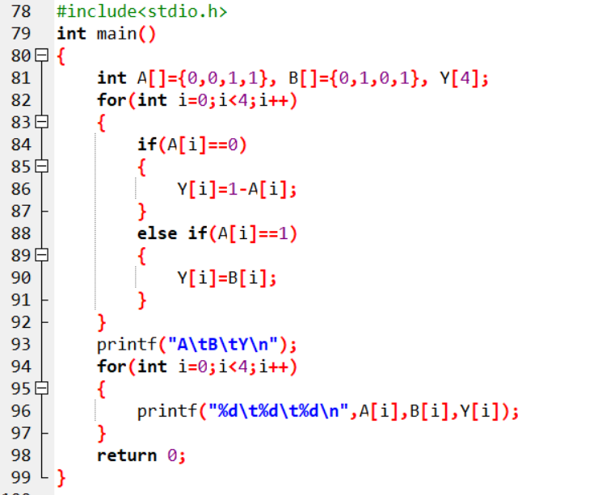

**Output:-**

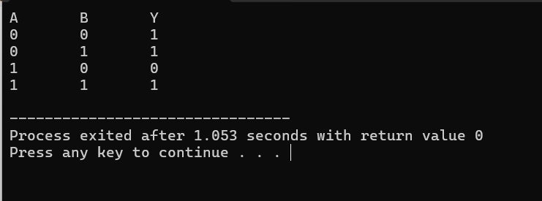

**Q5)** **Given a table data below, Write a program to store the data in a structure.**

|  |  |  |
| --- | --- | --- |
| **Customer Name** | **Customer ID** | **PAN No.** |
| **Amar Singh** | **123432** | **AQGBA32345W** |
| **Abhay Kumar** | **365289** | **APDBC36745U** |
| **Anish Agarwal** | **265785** | **AWHBC45623W** |
| **Aman Shaw** | **765234** | **ARDEB56894U** |
| **Abir Banerjee** | **956742** | **BQCBH37954W** |

**Program instruction:-**

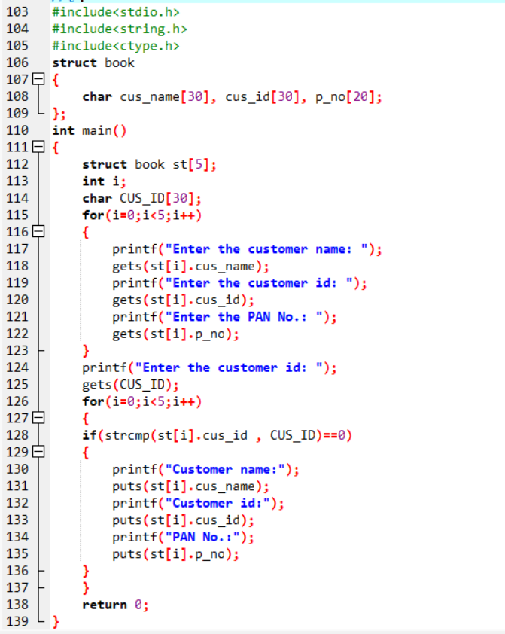

**Output:-**

